Chapter 18, Solution 7.

- Take the derivative of f₁(t) and obtain f₁’(t) as shown below.

2δ(t)

0 1 2 t

-δ(t-1) -δ(t-2)

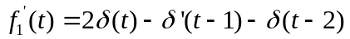

Take the Fourier transform of each term,

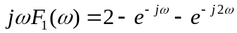

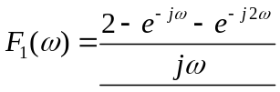

- f₂(t) = 5t

